Home-Learning Ideas – Theme: Easter Traditions
When a learning activity has been completed, the box can be coloured in. When the all the boxes have been coloured – try the challenge boxes
English  Draw all the characters in the book with their names. Do this in the order they appear. | English  Write some labels/captions or sentences to describe each character. | English Challenge  Write your own story based on 'The Story of the Easter Bunny'.  Choose a new animal and you could also choose a different celebration eg. 'The Story of the Easter Chicken' or 'The Story of the Birthday Squirrel'. | Maths  Y1 – Learn to count in 2's up to 20.  Learn to count in 5's as far as you can up to 50.  Y2 – choose a multiplication table you don't yet know well and learn it  2 x 5 x 10 x  Can you make a drawing to show your multiplication table? For example…  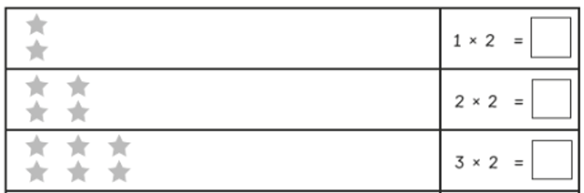
Key Text: The Story of the Easter Bunny by Katherine Tegen

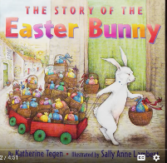

https://www.youtube.com/watch?v=xP__j1Fviaw&t=181s

English  This book has the American spelling of the word 'colour'  'colour' is a tricky word  Learn how to spell it correctly using the following  - Look carefully at the word  - Find the tricky bit  - Say the word  - Cover it up  - Write it  Did you get it right? Keep practising until you can spell it  Choose three other words in the text you like but can't spell yet. Do the same (make sure you do the English spelling).  Art  Draw an Easter scene using wax crayon. Paint a watered down paint mixture over the top. | English  Choose your favourite bit of the story.  Draw the picture to show it.  Label it with words and phrases to describe what you can see.  Explain why you like that bit of the story.  Art  Make a collection of different patterns eg. zig-zag, swirly, triangular, floral.  Decorate inside the egg outline using some of these patterns.  Choose 3 colours to decorate it – you can use the same colours in pencils, felt-tips, paints etc so it is mixed media. | Maths Challenge 1  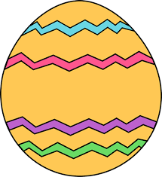  Pick a number from the boxes above and do the following  to the original number:  (see next page)  Art Challenge  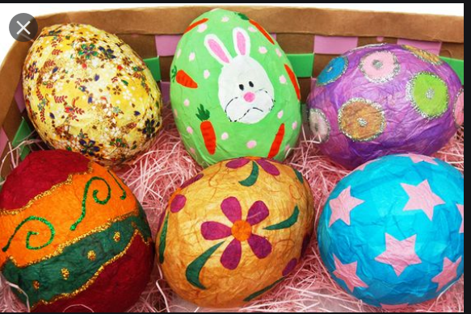  Find out how to make a papier mache Easter egg and decorate. You could put it in your window or hang it outside your house to cheer up anybody who is passing. | Maths Challenge 2  Have a go at the Easter word problems.  Each page gets harder.  Y1 – focus on the first page.  Y2 – start on the first page and go as high as you feel you can.  Don’t forget – you can use counters to help you.  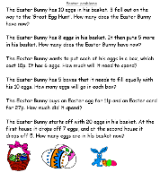 | Maths  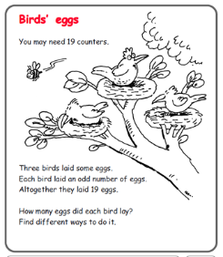  If you don't have counters, you could use 19 lego bricks; or 19 sweets (don't eat them until you're finished though) or you could make some counters out of card.  PE  Try out the Joe Wicks workout for primary schools at 9:00 every day:  https://www.youtube.com/watch?v=o-ZCP91mjeE  https://www.thebodycoach.com/blog/pe-with-joe-1254.html
  7 | 10 | 23 | 42
  Y1 | Y2
  Say it  Write it correctly  Write it as a word  Double it  Count on 2s up to/near to 20  Add 3 more  Take away 3  Say what is 10 more  Put it on a number line between 1 and 20 | Say it  Write it correctly  Write it as a word  Is it odd or even?  Double it  Half it if you can  Count on in 2s up to/near to 50  What is 10 more?  What is 10 less?  Add 8  Subtract 5  Put it on a number line going up in 10s from 1-50
Science

Make a wind turbine – see attached pdf from Whizz Pop Bang magazine school science club resources.

Science

RE

Watch the video about the Christian celebration of Easter
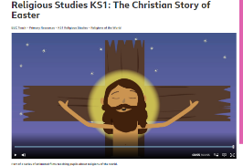

https://www.bbc.co.uk/teach/class-clips-video/religious-studies-ks1-the-christian-story-of-easter/zhgv47h

 |  | RE  Create Easter cards to send to people in your family.  Make a cross out of materials you have at home and display it  in your window.  Think about how you can help people during this time in our lives | Geography  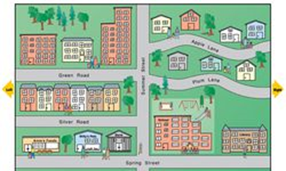  Draw a map to show the route of your daily exercise

