Home-Learning Ideas – 2 Theme: Easter LKS2 (Y3/4)
When a learning activity has been completed, the box can be coloured in. When the all the boxes have been coloured – try the challenge boxes
English – before reading  - Make a list of all the Easter traditions you and your family know about – do you know why we have that tradition? Make a prediction next to each one eg. I think Easter eggs…  - Make a list of all the special foods you and your family enjoy at Easter – do the same as above – predict why you think we might eat that food at this time of year | English – before reading  - Collect all the words from the text that are in bold print  - Put them in alphabetical order  - Now make a glossary by finding out the meaning of each one  You may want to use a dictionary, if you have one at home or you could use an online dictionary/thesaurus like Word Hippo – www.wordhippo.com | English Challenge  - Find out about two other Easter traditions eg. Easter bonnets, egg-rolling etc.  - Make an information leaflet, or put together a PowerPoint presentation, for a grown-up in your family to explain where our popular Easter traditions have come from. Make sure you:  - Include at least 5 traditions.  - Write at least one paragraph about each one.  - Use the correct terms/words.  - Put in a picture for each section which is labelled and has a caption. | Maths  Hit The Button  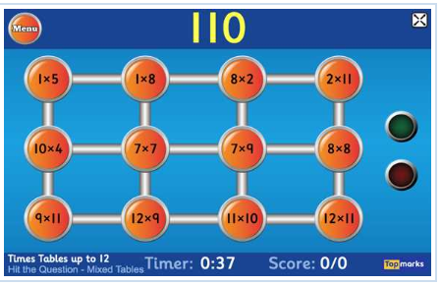  Play the game to practise your timestables.  https://www.topmarks.co.uk/maths-games/hit-the-button | Maths Challenge  Pick one of these numbers and then. Start easy and then challenge yourself...  - Double it  - Halve it  - Multiply it by 5  - Multiply it by 10  - Divide it by 10  - Add three tens  - Subtract 10  - Write a problem with your number in it (+ - × ÷). It could involve £ p cm metres.
  14 | 40 | 86
English  - Read the text.  - Look at your predictions.  - Were any of them close?  Answer these questions: mild hot spicy  - Name three facts that you have learnt about Easter eggs.  - Why do people sometimes paint and decorate eggs at Easter time?  - What type of animal was the original Easter bunny?  - Why do children sometimes leave carrots for the Easter bunny?  - What was the name of the Anglo Saxon goddess of harvest?  - Why do you think eggs are a symbol of new life?  - Why do you think eggs used to be boiled hard before decoration?  - What word tells us the Easter bunny tradition went all over America?  - In the legend about Mary Magdalene, why do you think the eggs turned red when she saw Jesus had come back to life?  - What two facts about Osterhase suggest this animal was probably a myth?  - Where do you think the word 'Easter' comes from? |  | Key Text: Easter Traditions  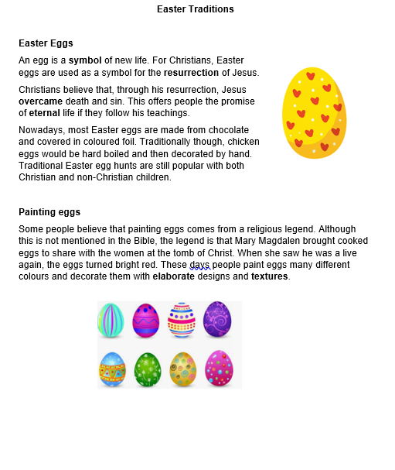 | Maths Challenge  Suzie the Snake - attached  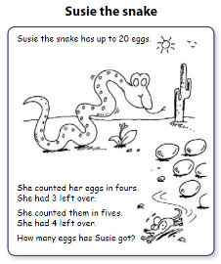  What if Suzie had up to 40 eggs?  Can you predict what other number of eggs Suzie could have? | E-Safety  Don't forget how to stay safe when you're using  the internet at home.  Look at some of the help on…    https://www.thinkuknow.co.uk/
Science
https://www.science-sparks.com/crash-test-eggs/

Build a vehicle to protect an egg or adapt a toy vehicle you have already.

INSTRUCTIONS FOR CRASH TEST EGGS
Design a car to hold the egg so it doesn’t crack on impact with a solid object (use a boiled egg – less mess and could be eaten afterwards if not damaged!!)

THINK ABOUT HOW TO PROTECT THE EGG.
- Build a protective cage.
- Add protective materials: bubble wrap, cotton wool etc.
- Try an air bag – balloon.
- Could you add some suspension?
Can you think of anything else? Would changing the type and size of wheel help?

CRASH TEST EGGS EXTENSION IDEAS
Try a different method of protecting the egg and design a test to investigate which method of protecting the eggs works the best.
Does your solution still work if you release the car down a ramp?
How can you make your comparisons a fair test?
If you enjoyed this activity we’ve got lots more fun Easter STEM Challenges to try.
RE/PSHE  Watch the clip here  https://www.bbc.co.uk/bitesize/topics/ztkxpv4/articles/z4t6rj6  Which Easter traditions are mentioned and why do we have them?  Read underneath about the days leading up to Easter.  Make a cartoon strip, with captions, to illustrate what happened in the week leading up to the first Easter. |  | Art  In a notebook, make as many different patterns as you can or record ones that you have found  Now, draw the outline of an large egg (or download one here https://www.twinkl.co.uk/resource/t-t-5015-design-an-easter-egg-a4-worksheet  Use some of your patterns to decorate it  Now colour it in. You could use warm colours (reds, yellows, oranges) or cool colours (greens, blues, purples).

