Home - Learning Ideas – 2 Easter UKS2 (Y5/6)
When a learning activity has been completed, the box can be coloured in. When the all the boxes have been coloured – try the challenge boxes
English  Before Reading / watching  Divide an A4 piece of paper into 8 boxes.  At the top of each box, write the title of an Easter tradition eg. Easter eggs.  Using bullet points, list as many facts as you know about each of these traditions. | English  Watch the clip about why we have Easter eggs and take notes on:  - Key facts  - Key dates  - Key amounts  What have you learnt? Fill in the fact box relating to Easter eggs.  Read the information underneath (or on the sheet) and identify / underline the 2 or 3 most important facts in each paragraph.  Can you now add anything in to your original fact boxes? | English Challenge  Create a booklet to share with an adult which describes and explains what you have learnt about Easter traditions here and around the world.  Your booklet must contain:  - A contents page  - Well-written information about different aspects and traditions (think about how you will order your booklet)  - Key facts boxes  - Labelled illustrations  - An index  - A glossary of key words which you have identified for explanation (at least 10) | Maths  How many eggs?  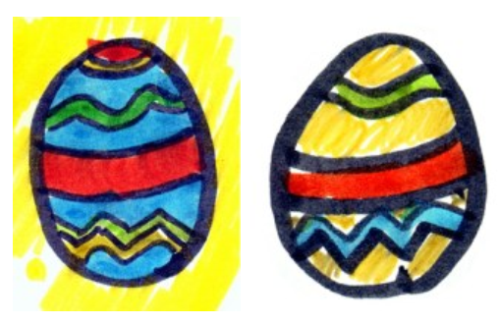  Peter, Melanie, Amil and Jack received a total of 38 chocolate eggs.  - Jack had one less than Peter.  - Peter had 5 less than Melanie.  - Amil had half as many as Melanie.  - Peter had 2 more than Amil.  How many eggs did each person have?  https://nrich.maths.org/939  Create your own logic problem. | Maths Challenge  Put a number in your Easter egg. Use this number for each of the following:  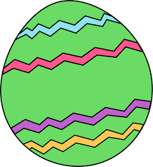  - Add 224  - Subtract 79  - Multiply by 8  - Divide by 3  - Multiply by 1000  - Divide by 100  - Find 50%  - Round the number to the nearest 100  What strategy did you use to work out each answer?  (Mental, jottings, written?)  Can you find more than one way to work out each answer?  Can you work out answers for each number?
  Mild | Hot | Spicy
  54 | 324 | 489.6
English  Divide an A4 page into 6 boxes.  Put the names of the following countries/places into a box each:  - Greece  - Ukraine  - France  - USA  - Northern Europe  Read the information on  https://www.bbc.co.uk/newsround/47975475  Now fill in your fact boxes with key facts and information.  Choose another country and research an Easter tradition from there.  Put the information in the 6th box. | English  Explore one of the links on https://www.bbc.co.uk/newsround/17597617  Make a poster or PowerPoint presentation about this subject. Include:  - Title  - Any facts relating to dates and numbers  - Any facts relating to key information  - Any facts that might surprise people  - Your own thoughts and opinions about this | Key Text – Written and Visual  Easter - https://www.bbc.co.uk/newsround/17597617    Easter Traditions Around the World  https://www.bbc.co.uk/newsround/47975475 | Maths  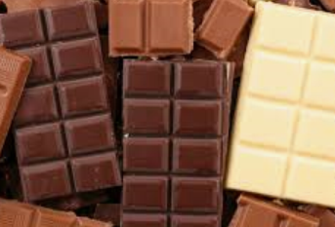  Ben, Amir and Whitney share a bar of chocolate.  Maths  Play some of the games at nrich…  Square IT:  https://nrich.maths.org/squareit  Countdown:  https://nrich.maths.org/6499  - Ben eats 4 tenths of the whole bar.  - Amir eats a quarter.  - Whitney eats $\frac{3}{20}$ of the bar.  How much of the chocolate bar is left?  Can you give your answer as a fraction?  Can you give your answer as a percentage?

Art  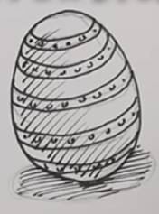  Draw some Easter eggs…  Practise your 3D sketching skills. Use different pencil techniques to shade in the eggs…  shading, hatching…  Try using different pencil and pens.  How are they different?  Which do you prefer?  Can you try sketching other things e.g. cup, | Computing  Catch It!  Can you create a 'Chase Game' using Scratch?  https://scratch.mit.edu/ideas  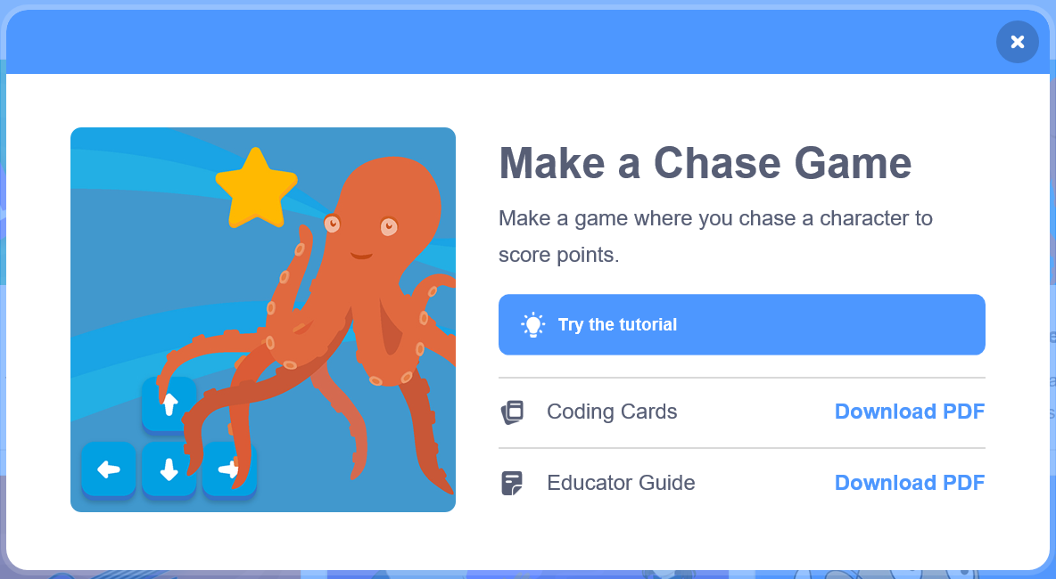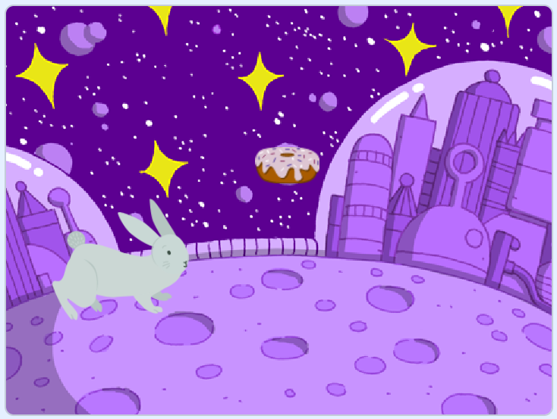  Lots of ideas, and tutorials (lessons) to help you on your way. Perhaps you can make the Easter bunny catch the flying doughnut...?  Save your work and send it in. |  | DT  If you get an Easter egg, take the box apart carefully and see how it is made.  Can you draw the net?  Can you create your own box?  Use paper to create net.  How will you strengthen it?  How will you join the sides?  Try making these containers using a pentagon?  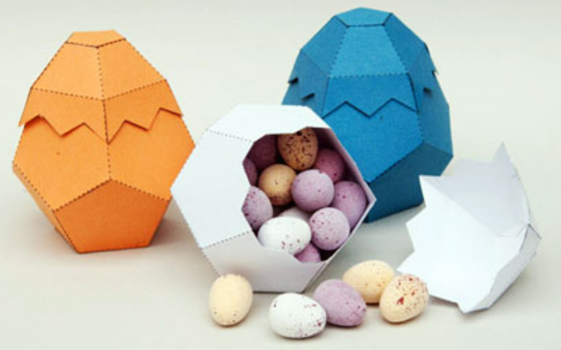 |  | PE  Link your PE and exercise with science this week.  How did James Campbell run a marathon?  https://www.bbc.co.uk/sport/scotland/52138624  Daily Mile at Home challenge…  https://thedailymile.co.uk/at-home/  Can you walk / run 1 mile in your yard / garden?  How long is your garden?  How many times will you need to run up and down?  1 mile = 1610 metres  Let us know if you succeed and how many laps you needed to do.
Geography  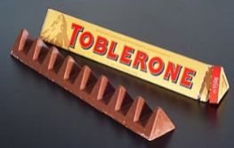  Toblerone chocolate was created by Emil and Theodor Tobler in 1908.  They lived in Bern, a city in Switzerland.  Find out about Bern and the area in Switzerland…  What is the weather like… rainfall, snowfall, temperature?  What's the area like around Bern… rivers, mountains, forests…?  How many people live there?  When / why did Bern start to develop?  What is Bern famous for?  What are the important industries in Bern today?  What is different about Bern to where you live?  Record what you find out.  You could create a poster, a leaflet or a quiz to test other people. |  | Science  Heart Beat    Watch this video to find out why your heart is so important.  https://www.bbc.co.uk/teach/class-clips-video/science-ks2-how-our-circulatory-system-keeps-us-alive/zhf76v4
E-Safety  Don't forget how to stay safe when you're using  the internet at home.  Look at some of the help on…    https://www.thinkuknow.co.uk/ |  | Activities 1:  - Measure your heart rate (pulse) when you are resting.  - Measure your heart rate after 5 minutes of different exercises e.g. stretching, walking, jumping, running.  Make sure your heart rate returns to its resting rate after each activity.  - Chose a way to record your results.  Activity 3:  - Find out and write an information poster / report about the heart in different animals: e.g. mouse, elephant, sparrow, shark… |  | Activity 2:  - Measure your heart rate when you are resting  - Complete 5 minutes of hard exercise e.g. running.  - Measure your heart rate immediately after the exercise and then every 3 minutes.  - Record your results on a line graph – don't forget to add the titles and labels.  Activity 4:  - Research and write down what you think are the most important 5 Top Tips to keep your heart healthy. Explain why each point is so important.

