
Our school helps us to walk with Jesus to be
the best that we can be’

Baxenden St John’s CE Primary School
Church Avenue Baxenden Lancashire BB5 2RQ
Tel: 01254 234 074 Email: bursar@baxenden.lancs.sch.uk

Year 4 - Weekly Newsletter
Hello Year 4,
This newsletter will share all of the learning opportunities that I have set up for you this week, as well as sharing some of the brilliant work you have been doing. There will be an updated newsletter every Monday so remember to send photographs of your activities and work to yearfour@baxenden.lancs.sch.uk.
Have a great week

Miss Abrahams x
Freddie has been working with his sister to create art from a pineapple!
Juliet has been busy carrying out scientific experiments and completing her creative curriculum homework! The experiment was using a light and a mirror to create a rainbow!
Sullivan has created a word search that he is going to send over to his grandparents in Spain!
English Activities
Poems with a structure
For the rest of the term we will be looking at Haikus. A Haiku has a specific structure. Listen to the Haikus in the link below.
https://www.youtube.com/watch?v=A6X1WiXyqKo

Write your own Haiku based on water! Film yourself performing the poem and send it to the class email address to be put on the class page!

Spelling and Grammar activities have been set on Purple Mash.

Lancashire Team English Planning
Each week we will also be updating our class pages on the website with English planning written by the Lancashire English team. This week the theme is Fantastic Beasts. Have a look and give the activities a go!
Creative Curriculum Activities
Think about how you could present your work. You could use Purple Mash, Word or create something and take a photo to send to our class email address!
- Purple Mash: Activities on Egyptian Gods
- Purple Mash: Activities on Rivers
- Purple Mash: Read Chapter 3 of ‘Beth and the Nile’ and complete the related activities.
- Create your own abstract art based on water.

Remember to stay active

Let’s Share- Year 4’s Home Learning Fun
Please email photos of your work and activities and they can feature on next week’s newsletter.
Also, please don’t worry if you don’t manage to complete all of these activities. They are NOT compulsory but are there to offer you support.
Miss Abrahams
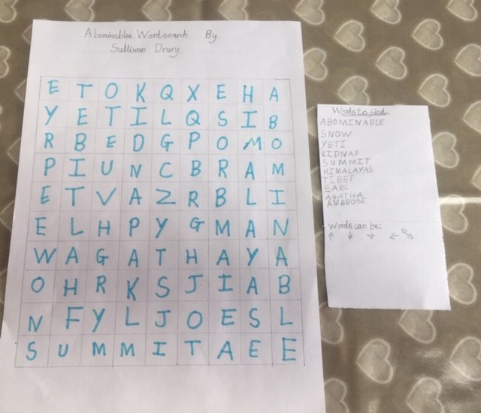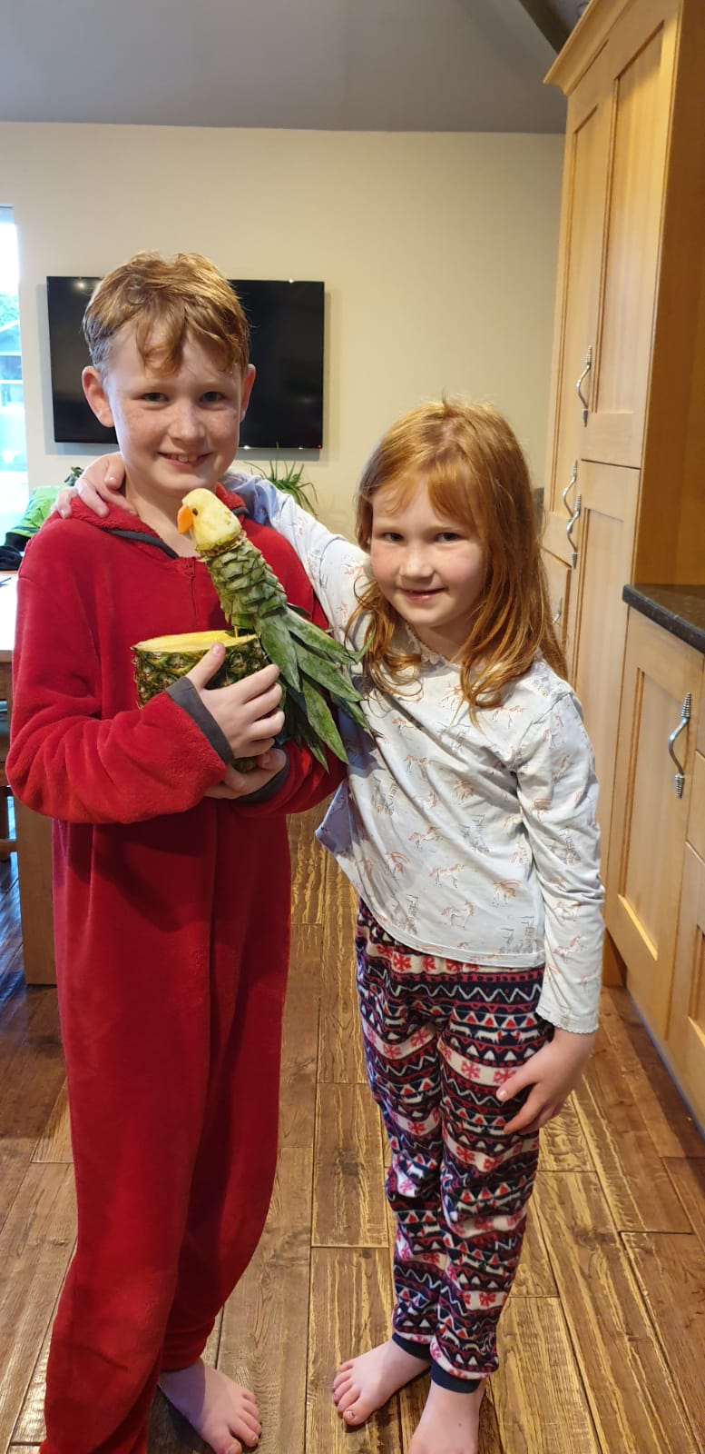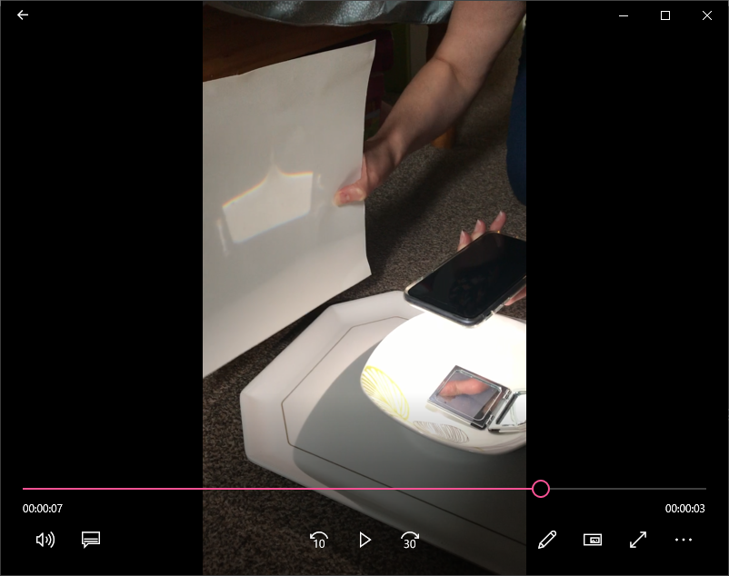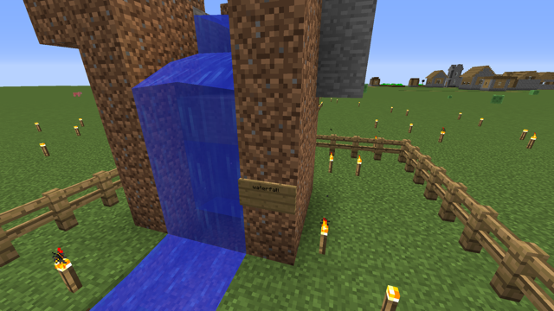

Maths Activities
TT Rockstars - Times Table Practise
Keep practising using ‘Soundcheck’ and battling against each other to improve your times tables!

MyMaths – Fractions
- Tenths and Hundreds
- Fractions as Operators
- Simple Equivalent Fractions
- Comparing Scalable Fractions
- Comparing Fractions – Bar Model
White Rose Hub – Fractions
White Rose Hub will be offering daily online lessons along with a follow up worksheet (on the class page). Take photos of your completed work and send them to the email address!
https://whiterosemaths.com/homelearning/
BBC Home Learning-
The BBC will also be offering daily maths lessons which will be available on their website and also through BBC iPlayer.
https://www.bbc.co.uk/bitesize/articles/zn9447h

Reading Activities
All children in year 4 can now log in to Active Learn. This is a website for children to read ebooks and answer questions about the text in a fun and interactive way.
To log in: visit: https://www.activelearnprimary.co.uk/login?e=-1&c=0
Username: firstname.initial of surname
​For example: joe.b
Password: year4
School code: jstr
Please monitor that your child is only accessing their own account and if you think someone else has accessed your child's account please get in touch using my email address.

Freddie has been drawing his favourite Fortnite Character!

