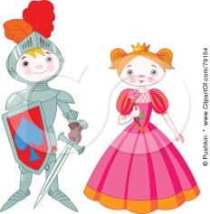The Knight and Princess Quest
Halving and Doubling Game

A game for 2-4 players.
Equipment:
One board game
One figure for each player
set of six cards
One die
One number line

How to Play:
You have to get the knight and the princess safely back to their castle!
Place the cards face down in a pile. Take turns to roll the die and move along the board. When you land on a number, work out the answer to the question. If you get it right you stay where you are. If you get it wrong you go back one place. If you land on a square pick a card and follow the instructions. Beware, these cards could be good or bad! The first one to the castle wins!
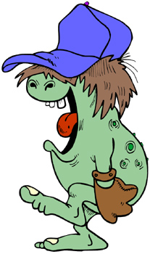

Ouch! You meet a troll who trips you up and throws you in a pond. It you takes ages to dry out. Move back 2 spaces.
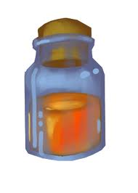

Oops! You were tricked into drinking a giggle potion. You can’t walk until it wears off! Move back 2 spaces.
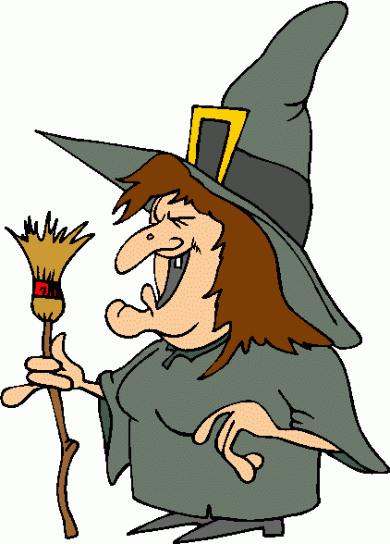

Oh no! You have been put under a sleepy spell by a crafty witch. This slows you down. Move back 2 spaces.

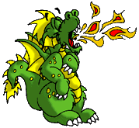

You come across a dragon who won’t let you pass, but you are clever and you use your shield to protect you and sneak past. Move on 3 spaces.


Well done! You have found the end of a rainbow. You collect a pot of gold. You buy some food and drink. This speeds you up. Move on 3 spaces.
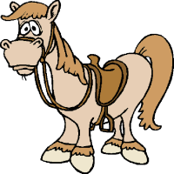

Yey! You bought a horse which has made you quicker. Move forwards 3 spaces.

Finish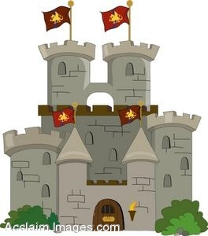
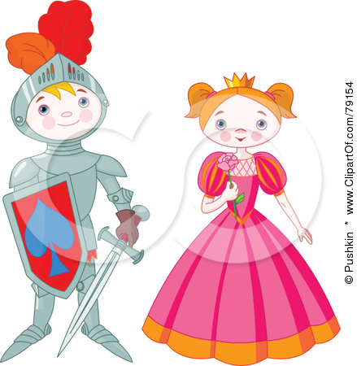Start
Halve
4

Halve
14

Double
7

Halve
18


Halve
8

Double
5

Halve
10

Double
4

Double
2

Halve
2

Double
3

Halve
6

Halve
12

Halve
20

Double
10

Halve
10

Double
9

Halve
14

Double
8

Halve
16

Double
7

Double
6

Halve
2

Double
5

Halve
10

Double
4

Halve
8

Double
3

Double
2

Halve
6

Double
10

Halve
4

Halve
2

Double
8

Halve
4

Double
7

Halve
10

Double
6

Double
5

Halve
6

Double
4

Halve
4

Halve
2
Double
2

