Let’s Share- Year 1’s Home Learning Fun
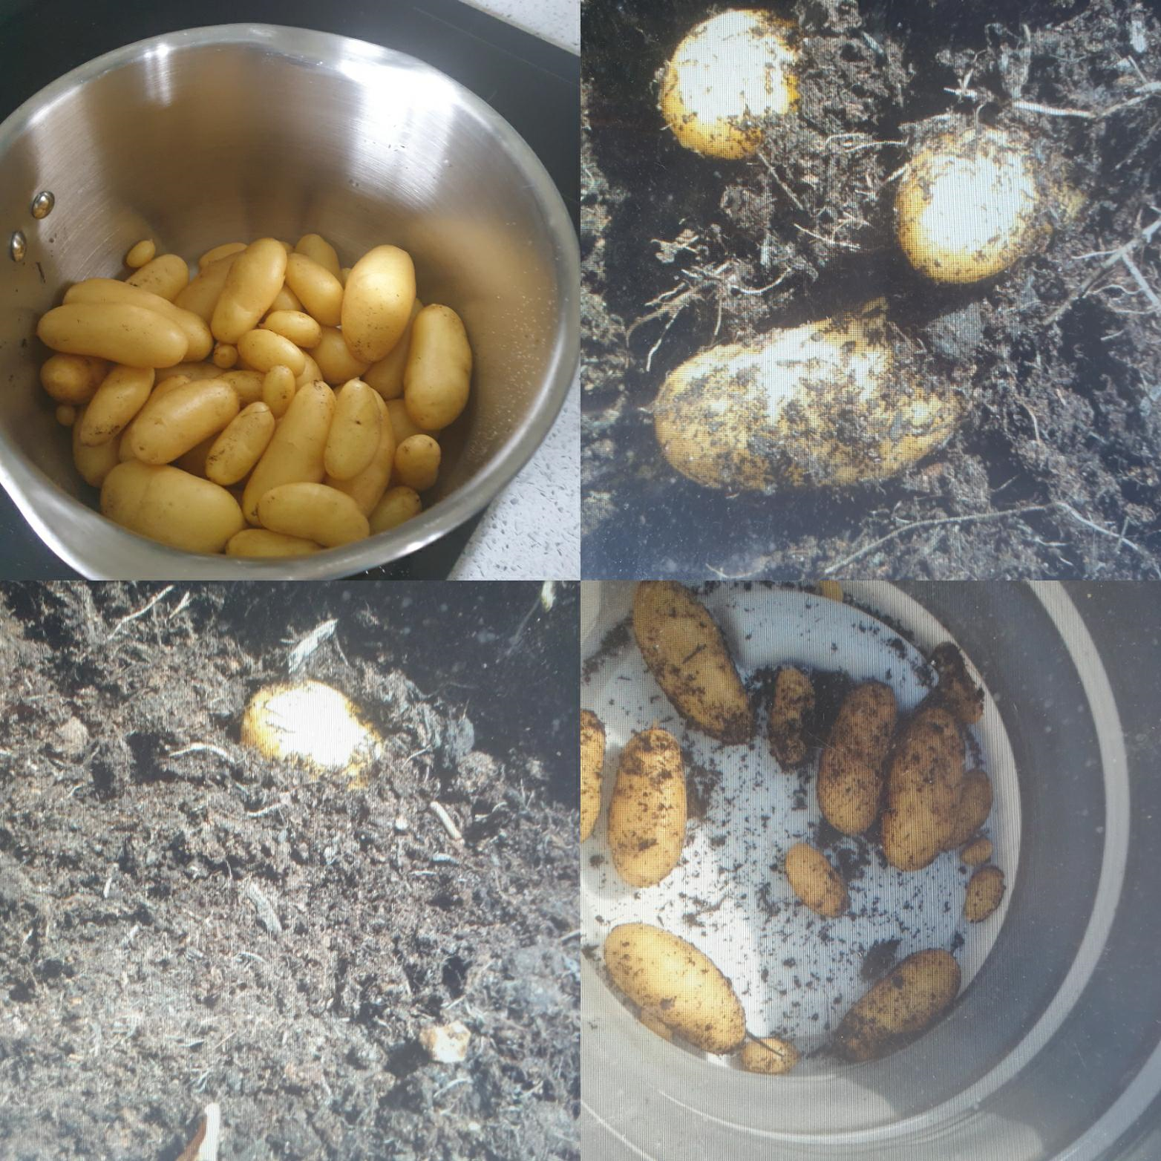
Aveline has been busy completing lots of Purple Mash and sending me her daily maths and English work based on The Jolly Postman, where she even found time to write and post her own letter to her Aunty.
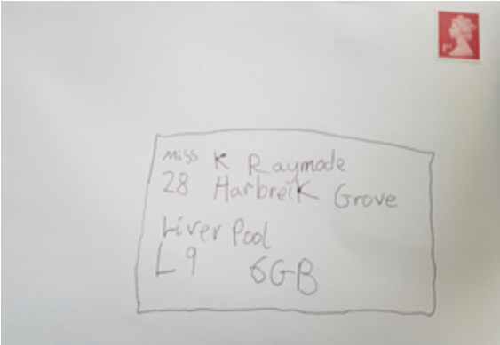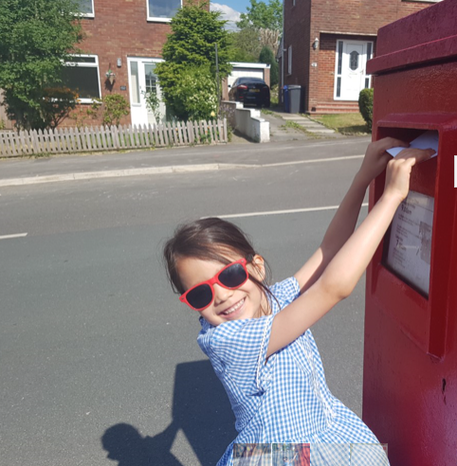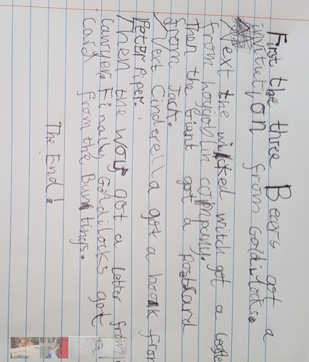
Alice is gaining lots of confidence and Logan has been enjoying nature and keeping active
independence completing her maths work. by climbing trees and learning to ride his bike.
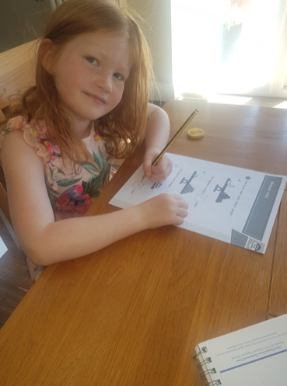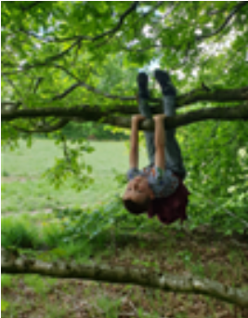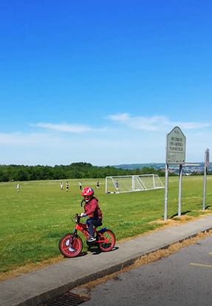
Rebecca has sent in lots of Purple Mash work and has even found time to walk over 50 miles raising money for baby Erin and Alder Hey Children’s Hospital! It was lovely to see Rebecca last week walking along the old railway lines as I went for my daily walk too!
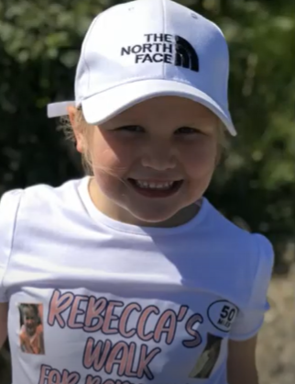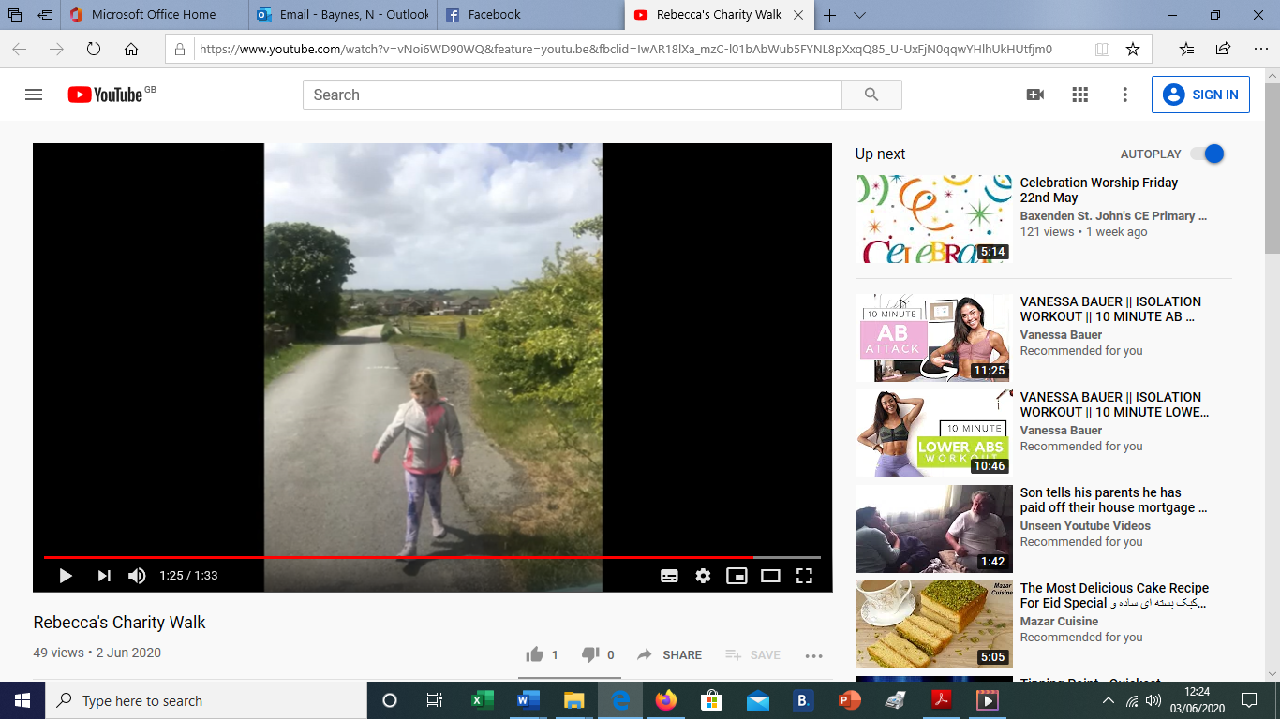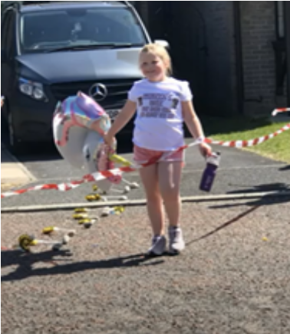
I’m missing you all a lot and hope to see you all soon. Take care
Share what you have been doing at yearone@baxenden.lancs.sch.uk


The second potato plant, the regional potatoes, were harvested this week. Again, we got lots of potatoes form our plant. They came in very useful as my eldest son, Tom, celebrated his 18th Birthday on Sunday and we had them for his birthday tea! Delicious!

