‘Playmate’ – by Sen Liu & KunZhan Tao - STORY MAP

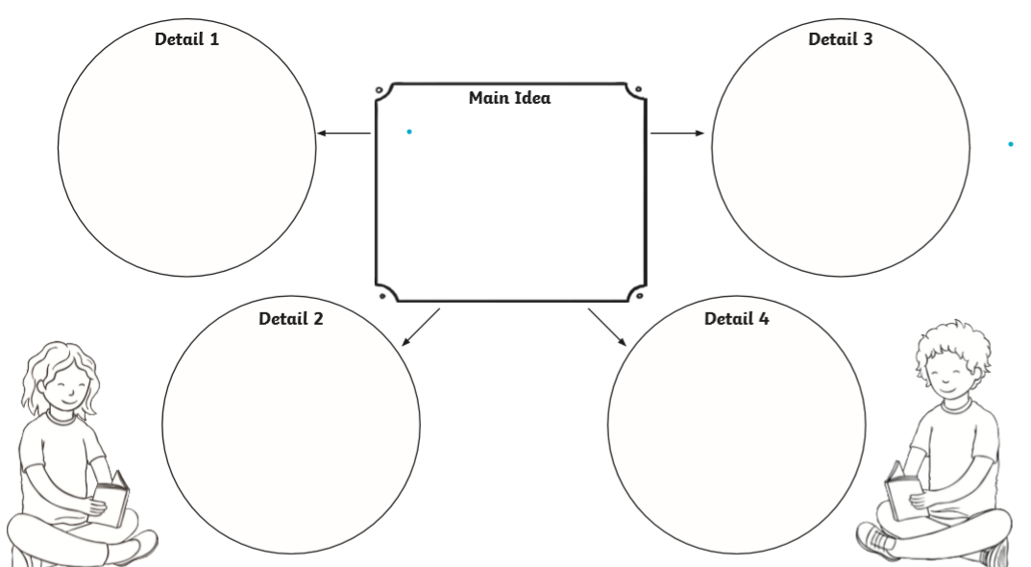
The boy woke up and started playing with the robot again. They were reunited!
The boy had a bad dream. In his dream, the robot tried to save him.
His friend (the little girl) was cross with the boy and stormed home.

The boy’s friend came to play, and the robot spoiled the game.

The boy threw the robot in the cupboard.
A boy loved playing with his
robot toy.
A year later the robot still
wanted to play but the boy
was getting annoyed with it.

