
Our school helps us to walk with Jesus to be the best that we can be’
Baxenden St John’s CE Primary School Church Avenue Baxenden Lancashire BB5 2RQ Tel: 01254 234 074
Email: bursar@baxenden.lancs.sch.uk

Year 1- Weekly Newsletter Summer 2 W5
Hi Year 1, I hope you’ve had a lovely week and have enjoyed your learning. It was lovely spending time in school with some of you and to all those at still learning at home-we still miss you!
Well done to Alicia and Lola who were our “Stars of the Week”

This newsletter will share all of the learning opportunities I have set up for you this week, as well as sharing some of the wonderful work you have been doing. There will be an updated newsletter every Monday so remember to send photographs of your activities to yearone@baxenden.lancs.sch.uk
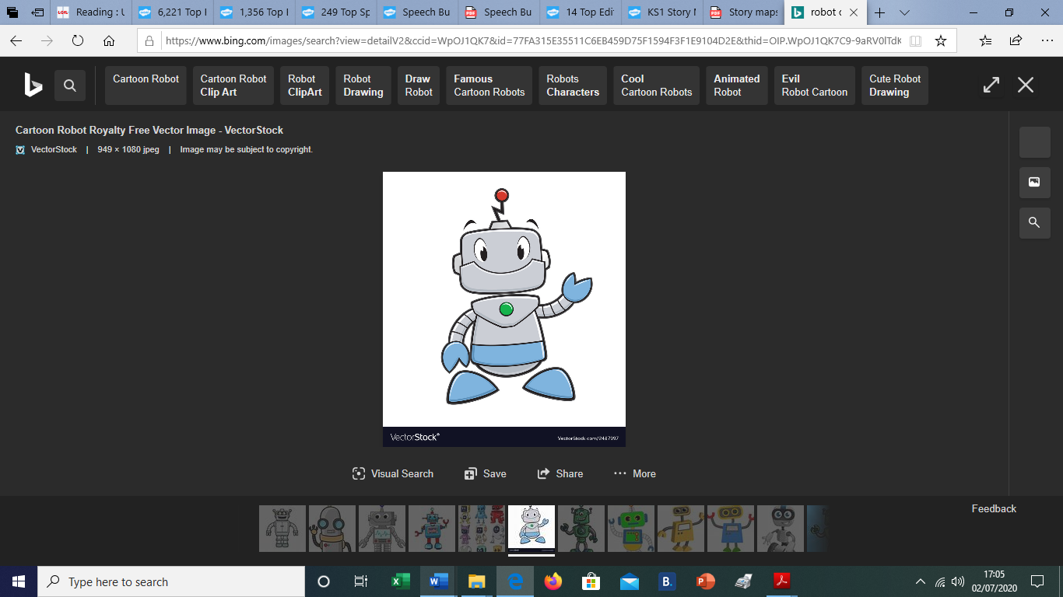
Phonics/Reading Activities
Select ideas from….
New phonics work has been set on Purple Mash. Focus adding ing, ed and er to verbs. Within the documents are two activity sheets. A dictation passage for writing in missing words and a look cover write check sheet.
Books are set on Active learn. Login to phonics play https://www.phonicsplay.co.uk/ Explore phase 4 and 5 activities. Keep learning to read and spell your high frequency and common exception words. User name: march20 Password: home Letters and Sounds phonics scheme have now produce daily videos to support phonics at home. Please see the additional letter in the documents titled Phonics Lessons Letters and Sounds Parents information

Creative Curriculum Activities
2dos have been set covering our new topic of robots. Have a look at the creative Curriculum grid and select some tasks over the next few weeks
If you didn’t get chance to complete your Sports Day @Home 2020 due to the weather, continue with it this week – See the presentation PPT to take part in out Sports Day Activities and send in your Personal Bests to earn points for your house.
National Sports Week Challenge: Continue to send a “Healthy Selfie” or a “Sweaty Selfie” to the class email to help us celebrate National Sports Week.
Your healthy selfie could include you eating a healthy meal or snack, completing some mindfulness challenges or drinking plenty of water. Your sweaty selfie could show a post physical activity photo, walking, running, playing on a trampoline, cycling.
#Keepactive Take a look on the “Home Learning” Page of the school website and scroll down to PE. Challenge yourself with the Lancs School Games stay home programme or win yourself some prizes by taking part in HRVSSP Virtual Challenges
English Activities
Robots ; Follow the planning and links from the Lancashire Document. Writing sheets saved
in the blog.

Maths Activities
Pick from
White Rose Hub My Maths/Twinkl
Use the link https://whiterosemaths.com/homelearning/year-1/ to find video tutorials. Open the relevant worksheet from documents on the school website. This will open in a PDF document. For each worksheet there is also and Answer Sheet. Don’t worry if you can’t print this out just use the add notes icon and use your mouse to write and save it. | As an alternative have a look at the Twinkl resources provided.  Video links to consolidate previous learning within this topic.  https://www.bbc.co.uk/bitesize/topics/z3rbg82
Lesson One: Finding ½ (1)  Lesson Two: Finding ½ (2)  Lesson Three: Finding ¼ (1)  Lesson Four: Finding ¼ (2)  Lesson Five: Grammarsaurus- (x2 sheets) Finding ¼ of a set of objects or unit | Fractions learning from home activity book.  Work through the book at your own pace.
Don’t forget to log in to TTRS and continue with your times tables. Use your times table knowledge to counts 2p 5p and 10p coins.

