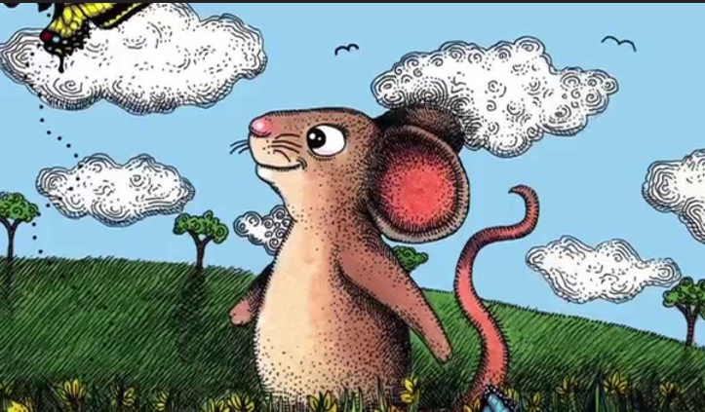

Reception to Year One Bridging Unit
Harry The Happy Mouse

Narrative
Learning outcomes

I will be able to write my own story
- using capital letters
- finger spaces
- full stops
- applying my phonics to segment and spell

