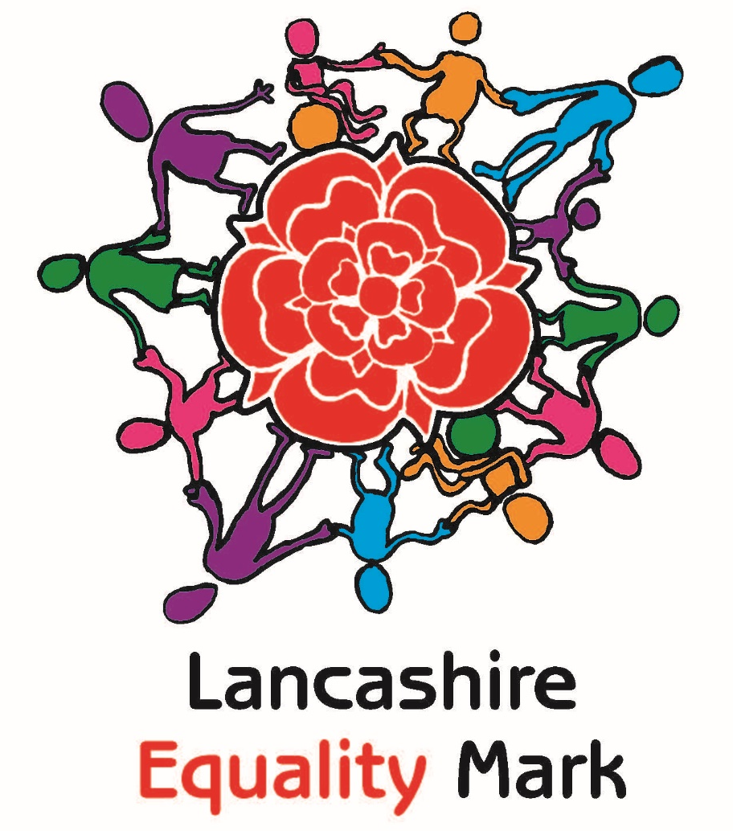

Baxenden Action Plan Year 2

Name of school: Baxenden St John’s CE Primary School Date: Written November 2022
Overall target: Equality & diversity is embedded within the wider curriculum to enable all stakeholders to flourish in a culture that values and respects beliefs and lifestyles of people outside of their regular experience.

Intended impact:
- Pupils will be given regular opportunities to learn about the beliefs and lifestyles of people outside of their regular experience and will be taught tolerance and acceptance of all communities
- SL have included diversity plans and resources into their subject area and teachers actively seek opportunities to be culturally diverse within lessons
- Policies and procedures will always consider the impact on those with protected characteristics.
- Protected characteristics will be embedded into the curriculum and children will be able to talk about diversity
Current situation / critical analysis |  | Required changes
We have an ‘Equality Governor’ who is also a member of the newly formed ‘Vision & Ethos’ committee, which makes decisions and suggestions based on the vision statement – these are reported back to FGB via the vision and Ethos Committee  We achieved the ‘Religion & Belief’, ‘Socioeconomic’ and ‘Gender’ Equality badges in October 2022.  Race Equality  This is a strength. As a church school, we follow the Blackburn Diocesan Syllabus which includes ‘Questful RE’ and ‘Understanding Christianity’. Different world religions as well as Christianity around the world is woven throughout the scheme. We have a yearly ‘cultural diversity’ week that celebrates different religions as well as black history.  Sexual Orientation Equality  This is an area that can be developed and enhanced further, building on our work in achieving the ‘Gender and Sex’ Equality badge, and being made more explicit.  Disability Equality  This is satisfactory but could be improved further. We have children with disabilities in school (including ASD, diabetes, deafness, Autism and Cerebral Palsy) and ensure that these disabilities are not a barrier to learning and enrichments. However, more need to be done to actively promote understanding of these characteristics. |  | - Involve and inform parents through use of the school website and social media pages  - Involve the governors ‘Vision & Ethos’ committee with decisions and audits regarding equality on a more regular basis – half termly  - Resources and books in school need to reflect diversity and support positive stereotypes – whole school display plus classroom libraries  - Staff to receive appropriate training where required to improve their knowledge and skills when thinking about and planning for equality and diversity  - Policies and procedures will always consider the impact on those with protected characteristics  - To ensure there are no institutional barriers to children achieving their full potential and flourishing in line with the school’s vision statement and distinctive Christian distinctiveness  - Awareness days to include specific disabilities
Actions | Costs / timescale / staff lead | Success criteria | Evaluation
General Targets
To use social media and the school website to promote understanding of community cohesion, equality and religious beliefs with parents and the wider community | Class teachers  HT | - Teachers update website on a half termly basis.  - Equality page with details of what we have done and plan to do  - PTFA and pupil voice involved in decision making and auditing
To continue to develop the role of an ‘Equality’ governor within the Vision & Ethos committee | Governors  HT | - Equality governor to be involved in audits, monitoring within school and feeding back to other governors in V & E Committee – half termly  - V&E have monitored learning environment for equality
Update all policies with the equality statement and ensure the equality objectives are up to date and re-visited | Governors  HT  Staff | - Staff meeting to discuss objectives and equality mark  - Governors aware of equality policy and statements
Training for all staff (teachers and TAs) to be planned around equality and diversity across the curriculum and how we can develop even further | HT  Staff | - Equality, Diversity and Equity training from BDBE  - Staff training on protected characteristics – provided by HT (Equality Lead) and attended by Equality governor
Parent and pupil voice used to help implement ‘No Outsiders’ into worship and PSHE curriculumj | HT/SLT  Equality Governor | - Parents informed of No Outsiders and shown resources – involved in decision process  - School Parliament involved in how 3 badges can be promoted
Race Equality

‘Cultural diversity’ week linked with black history in the autumn term – learning to progress each year | HT to book  £800 for PRAGS (2 days)  £400 for Imran (1 day) Muslim leader | - Scrapbooks with evaluations from children  - LCC Black history pack to celebrate BHM  - Different visitors and experiences with learning (building upon knowledge from previous teaching if repeated – Sikhism rather than Hinduism)
List of religious and other celebrations/events to refer to throughout year (World Religion Day, Diwali etc) | No cost  HT | - Draw attention to festival and religious days during whole school worship (include Picture News)  - Picture news used on a weekly basis to ensure prejudice is discussed
Ensure there are a variety of books & resources that represent Diversity (with a focus this year on Race as well as religions & different families) | £350 No Outsiders  HT  Subject leaders | - Range of books & resources reflecting race, disability, religious diversity and different families in each class (Letterbox Library)  - Parents involved through Picture News on Newsletter  - Displays more varied and diverse with ‘real’ people - new display images carefully considered for +ive stereotypes.
Link with a Christian school through the ‘Amani’ charity and the LCC Linking Schools project | No cost  HT  School parliament | - New link to be established with multi-national school and a local school (Stoneyholme Y4)
Review the curriculum to ensure that diversity is planned for e.g. artists/scientists/musicians being studied from a range of cultures and backgrounds. | No cost  HT  School parliament | - Review progression in curr maps throughout the year to ensure a wide range of diverse artists/scientists and musicians so that all pupils can build an understanding of how many different people contribute to the world in different ways.
Sexual Orientation Equality

Ensure that when resourcing lessons (particularly PSHE) that positive portrayals of people from different backgrounds are used. | No cost  SL to discuss during staff training | - People studied have diverse backgrounds of race, religion, gender and disability and celebrated for their achievements  - Displays reflect diversity of people, places and languages (French, well-being, art, BHM etc)  - Subject curriculum plans show diversity and PSHE plans show sexual orientation
Staff to be trained on ‘LGTB’ awareness and parents offered a workshop/parents forum to be fully informed and involved | HT/SLT then cascade to rest of staff | - Staff avoid using language which reflects an assumption that everyone is heterosexual – they talk about 'families' or 'parents' instead of 'mums' and 'dads' and not boy/girl but ‘people’ and ‘team’ etc  - Parents involved in decision making as well as pupil voice
Information about local and national LGBT support organisations displayed |  | - Try to ensure that LGBT events and identities celebrated in an age appropriate way through worship throughout the year – e.g LGBT History Month in February and International Day against Homophobia, Biphobia and Transphobia  - Posters in the main Y5/6 corridor and upstairs in KS2
Ensure there are a variety of books that represent different families, professional roles & these are in a prominent place | £350 Letterbox Library  HT  Subject leaders | - Range of books reflecting religious diversity and different families to be prominently displayed - School Parliament set up display in hall (well-being’ and ‘diversity’) to showcase different books in weekly worship  - Invite parents in for science week to discuss jobs & point out jobs that don’t conform to stereotypes  - Books to be purchased from ‘No Outsiders’ and integrated into classrooms (Letterbox Library)
Disability Equality

Staff to receive training on trauma informed teaching, linked with how ASD presents and is different to trauma. | No cost – fully funded  Staff  Governors | - Staff more aware of unconscious bias & trauma informed teaching - strategies shared to ensure no individual or group are every disadvantaged in school.  - .  - Impact felt in the attitudes of staff towards troubling behaviour of children - staff will feel more confident when supporting ASD pupils across school.  - Autism awareness day will have been celebrated.
Begin to learn BSL signs and/or Macaton for songs and school prayer in collective worship. | No cost  HT | - Children and staff will have built up a repertoire of songs using BSL.  - All staff and children will be able to sign the school prayer.  - Deaf Awareness week will have been celebrated.
List of disability awareness events to refer to throughout year during whole school worships | No cost  HT | - Draw attention to disability days during whole school worship (include Picture News)  - Pupils involved in raising awareness of disabilities
SEN pupils/pupils with a disability need to continue to have funding and academic progress tracked | No cost  HT | - Accurate records kept for spending on interventions for individual children – the impact needs to be measured in results  - Use of Edukey (provision mapping) to support  - Accurate tracking of spending for children classed with having a disability – extra-curricular clubs/enrichments etc
(Total costs £2,000)
Projected Actions (for next academic year 24/25)
Update the whole school audit
Continue with link schools project as an independent with existing link school & continue links with sponsored child and African school.
Evaluate and continue with ‘No Outsiders: Everyone Different, Everyone Welcome’ book £17
Purchase Letterbox Library Packs to support diversity: £240
Investigate updating the uniform policy to ensure it is more affordable by children wearing PE kit in school

